Manage Corporate Use Case

Submitted to

Alpha Payments Cloud

Tarang Software Technologies Private Limited
Tarang Towers,
#400/2, Whitefield 100 ft road,
Hoody circle,
Bangalore, India
Phone: +91-80-41157777
WEB: www.tarangtech.com

© This document is exclusive property of Tarang software Technologies Private Limited. No part of this may reproduced in any form without written permission.

Document Change History

Ver# | Editor | Date | Reviewer | Approver | Changes made
0.1 | Sadanandh | 5th Sept 2012 | Bindu |  | Draft version
1.0 | Sadanandh | 7th Sept 2012 | Bindu |  | Base Version
1.01 | Sadanandh | 12th Sep 2012 | Ronan |  | Updated with Review comments
Table of Contents
1 Introduction 4
2 Use Case: SEARCH CORPORATES 4
2.1 User Interface Information 5
2.1.1 User Interface details for search corporates 5
3 Use Case: Add Corporate 5
3.1 User Interface Information 6
3.1.1 User Interface details for Add Corporate 6
4 Use Case: Edit CORPORATE 8
4.1 User Interface Information 9
4.1.1 User Interface details for Edit Corporate 9
5 Use Case: View Merchant List 10
5.1 User Interface Information 10
5.1.1 User Interface details for View Merchant List 10

Introduction

This document describes all the use cases for Corporate Management. It includes search Corporate, Add/Edit Corporate use case. Corporate is the second level in the hierarchy and is associated with the Bank in the system.

Use Case: SEARCH CORPORATES

Title | Search Corporate
Requirement ID | RID-1021
Actors | System Admin, APC User with appropriate privilege to search corporate
Description | Actor should be able to search for the Corporates
Use case trigger | - When Actor selects the “Manage Corporates” option from the main menu to search for the Corporates
Main flow / Flow of Events | - On choosing the “Manage Corporate“ option from the main menu, system shall display the list of recently created 20 corporate based on creation date in descending order which shall include the search criteria’s:  Corporate Name, Bank ID , Country and Status  Action - Search  - Actor shall enter the search criteria & click on “Search” button.  - System shall build the query based on the criteria entered & retrieve the relevant records from the DB & display it in the listing in the below mentioned format:  [Corporate Name,Corporate ID, Bank ID, Email Address, Contact No, Status, Country,Merchant List]
Sub-flow/Alternate Flows/ Scenarios | - If the actor does not choose to enter any data in the search criteria’s then the system shall retrieve all the corporate records.  - If there are no relevant records for the search criteria chosen; system should display an appropriate message saying “No Records found.”  - Depending on the status criteria chosen, Active/Inactive only the corporates in the respective status should be retrieved.  - If the actor selects the row and clicks on edit link at the bottom of the table, system should navigate the actor to the corresponding corporate edit screen. This feature will be detailed as part of separate use case.  - If the actor clicks on the “Add Corporate” link at the bottom of the table, system should navigate the actor to the Add Corporate screen. This feature will be detailed as part of separate use case.  - If the actor clicks on the “View” button under the merchant list column, system should navigate the actor to the Manage merchant screen with the merchant list for the corresponding corporate. This feature will be detailed as part of separate use case.
Assumptions
Pre-conditions | Actor should be logged into the system & has the appropriate privilege to search corporates.
Post-conditions | - Actor is able to retrieve the relevant corporate records from the system based on the search criteria chosen.
Status | Open
Issues
Business Rules | Search – Query should be for partial search. I.e. like “%string%”. So the minimal search keys that you enter should retrieve the maximum information. For ex: Search By name – “Car” should retrieve all the corporates with the alphabet “car” in their names.

User Interface Information

User Interface details for search corporates

Refer Manage Corporate screen of the storyboard (manager.html)

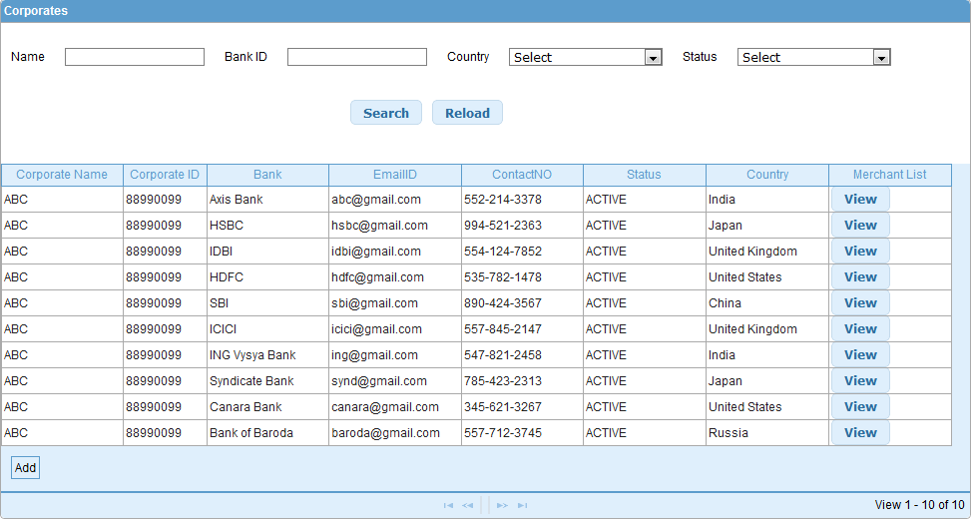

Validations for Search Corporate

Id | Parameter Name | Field Type | Special characters | Validations | Field Length | Possible Values | Additional Condition | Mandatory
1 | Corporate Name | Text Box
2 | Bank ID | Text Box
3 | Country | Drop Down
4 | Status | Drop down

Use Case: Add Corporate

Title | Add Corporate
Requirement ID | RID-1022
Actors | System Admin, APC User with appropriate privilege to Add corporates
Description | Allows the actor to add a corporate and associate the new corporate with existing Bank.
Use case trigger | - Actor chooses to click on “Add Corporate” link/button from the Corporate listing screen (Manage Corporates)
Main flow / Flow of Events | - System shall navigate the actor to the Add Corporate screen along with the following fields to be captured.  - details of the fields shown are:  - Corporate Name  - Corporate ID  - Contact Person  - Contact No  - Email Address  - Bank ID  - Address1  - Address2  - City  - Country  - State/Province  - Zip/Postal Code  - Currency  - Time Zone  - Language  - Actor shall enter the relevant information & Click on Save.
Sub-flow/Alternate Flows/ Scenarios | If the Actor enters the invalid data, the actor shall be navigated to the same screen with appropriate error message.
Assumptions | At least one Bank exists in the system for associating the Corporate to an existing Bank
Pre-conditions | The actor is logged in to the application. With appropriate privilege to add corporate
Post-conditions | - Add - New Corporate will successfully be created in the system and the Actor will be navigated to the corporate listing screen with the newly created corporate details.  - The new corporate details will be added to the DB along with the creation date and created by parameter values as the system date and logged in user respectively.
Status | Open
Issues
Business Rules | Corporate Name and Corporate ID should be unique in the system, and is entered manually. The length of the Corporate ID is 11 characters , with alphanumeric value support and no special characters allowed ( Note: same for Bank Id also)  Corporate will be associated with existing Bank  State and Contact number format shall be based on the country selected

User Interface Information

User Interface details for Add Corporate

Refer “Add corporate” screen in storyboard
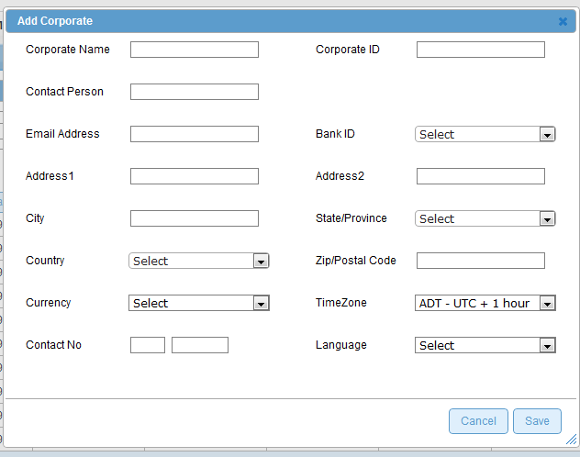

Validations for Add Corporate

Id | Parameter Name | Field Type | Special characters | Validations | Field Length | Possible Values | Additional Condition | Mandatory
1 | Corporate Name | Textbox
2 | Corporate ID  Contact Person  Bank ID  Email Address  Address1  Address2  City  Country  State/Province  Currency  Zip/Postal Code  Contact No  Time Zone  Language | Textbox  Textbox  Drop down  Textbox  Textbox  Textbox  Textbox  Drop down  Drop down  Drop down  Text box  Textbox  Drop down  Drop down |  | Valid email format  Specific to country  Specific to country |  | Default value for contact no is area code and number

Use Case: Edit CORPORATE

Title | Edit Corporate
Requirement ID | RID-1023
Actors | System Admin, APC User with appropriate privilege to Edit Corporate
Description | Allows the Actor to Edit Corporate
Use case trigger | - Actor selects the row from the corporate listing grid and clicks on the Edit link at the bottom of the table
Main flow / Flow of Events | System shall navigate the actor to the Edit Corporate screen along with the following fields to be updated.  details of the fields with the existing values shown are:  - Corporate Name  - Corporate ID  - Contact Person  - Contact No  - Email Address  - Bank Code  - Address1  - Address2  - City  - Country  - State/Province  - Currency  - Zip/Postal Code  - Time Zone  - Language  Actor shall update the relevant information and clicks on Save button.
Sub-flow/Alternate Flows/ Scenarios | If the Actor enters the invalid data , the actor shall be navigated to the same screen with appropriate error message
Assumptions | There exists at least one corporate in the system.
Pre-conditions | Actor is logged into the system & is in the corporate list screen
Post-conditions | The fields which are modified will be updated in the DB and the Actor will be navigated to the Manage Corporates screen. The old details will be retained in the DB.
Status | Open
Issues | None
Business Rules | Corporate Code cannot be modified, Corporate Name, and Email Address can be modified

User Interface Information

User Interface details for Edit Corporate

Refer “Add Corporate” screen of the storyboard

Validations for Edit Corporate
Will be updated later
Id | Parameter Name | Field Type | Special characters | Validations | Field Length | Possible Values | Additional Condition | Mandatory
1 | Corporate Name | Textbox
2 | Corporate ID  Contact Person  Bank ID  Email Address  Address1  Address2  City  Country  State/Province  Currency  Zip/Postal Code  Contact No  Time Zone  Language | Textbox  Textbox  Drop down  Textbox  Textbox  Textbox  Textbox  Drop down  Drop down  Drop down  Text box  Textbox  Drop down  Drop down |  | Read only  Valid email format  Specific to country  Specific to country |  | Default value for contact no is area code and number

Use Case: View Merchant List

Title | View Merchant List
Requirement ID | RID-1024
Actors | System Admin, APC User with appropriate privilege to View Merchant List for a Corporate
Description | Allows the Actor to View Merchant list for the selected Corporate
Use case trigger | - Actor selects the row from the Corporate listing grid and clicks on the View link in the Merchant List Column
Main flow / Flow of Events | System shall navigate the actor to the Merchant List screen along with the following fields displayed.  [MerchantID, Merchant Business Name, Contact Person, Contact No, Status, Country]
Sub-flow/Alternate Flows/ Scenarios | If the Actor clicks on the Corporate with no merchant associated with the selected corporate, the Actor shall be navigated to the same screen with the message – “no merchant associated with the selected corporate”.
Assumptions | There exists at least one corporate in the system.
Pre-conditions | Actor is logged into the system and has the permission to view merchant list for the selected Corporate.
Post-conditions | -
Status | Open
Issues | None
Business Rules | List the merchant list for the selected corporate

User Interface Information

User Interface details for View Merchant List
Refer Merchant List screen of storyboard

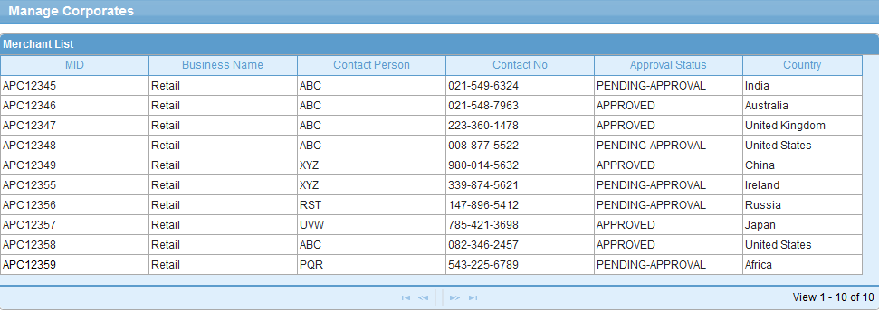

Validations for View Merchant List

None

